Personal Development Grant Application Form
North of England Institute of  Mining and Mechanical Engineers  Founded 1852  Royal Charter 1876 | 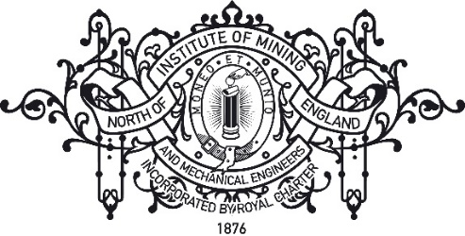

Personal Development Award Application

As part of its strategic objectives the Institute offers a small number of financial grants to its members in order to promote their ‘personal development’ in the widest sense. This could be any appropriate area of experience (e.g. supporting attendance at academic conferences, career enhancing workshops, research work or blue-skies individual development), and includes CPD events run by professional organisations such as IOM3. A typical award will be on the order of £100.

There is a limited amount of money available for such awards and the Institute anticipates supporting individuals with a number of small grants rather than making one or two large grants. The awards are designed to advance the personal development of the applicant (rather than, for example, being of benefit to a charity or organisation with which they might be working). Applicants are allowed to receive more than one award (but not in the same year) from the Institute but must include details of previous awards in their application. All applications must be in advance of the proposed activity.

- Awards are intended to support activities that would be unlikely to occur without modest financial assistance and are unlikely to be made where there are alternative sources of funding.
- Awards will not be made to cover the cost of compulsory activities within academic courses or of paid employment. Instead they must add value to the applicant in addition to these.
- Applications are more likely to be successful where they demonstrate clear evidence of thorough planning (including budgeting) and responsible organisation; alongside evidence of scientific, societal and/or personal impact.
- Judgements about awards are made in the context of the other applications received and the funds available. The system is therefore “comparative” – on some occasions even high-quality applications may be unsuccessful.
- Awards will not be made to individuals who are in debt to the Institute.
- Successful applicants will be required to produce a short (<1000 word) report for the Transactions detailing how the award was used and outlining the benefits gained.

Personal Development Grant Application Form
North of England Institute of
Mining and Mechanical Engineers

Founded 1852
Royal Charter 1876

Full Name:

Grade of Institute Membership:

Have you received any previous financial grants from the Institute?:
Job Title/Course of Study
(please indicate if full or part time)
Company/Department/Institution

Email address for correspondence:

What is the nature of the opportunity for which you are seeking an award?
Please outline the nature of the activity (1 page max)
Why is financial support needed from the Institute?
Please provide an outline budget together with details of other funding available or for which you have applied (1 page max)
How will this opportunity contribute to your personal development?
Bear in mind that this is your chance to 'pitch' for an award, please give a detailed account of the benefits this opportunity will provide.
Please also attach a 2 page CV
Please email this completed form (along with any other supporting documents) to office@mininginstitute.org. All documents should be submitted as a single PDF file.

