North of England Institute of  Mining and Mechanical Engineers  Founded 1852  Royal Charter 1876 | 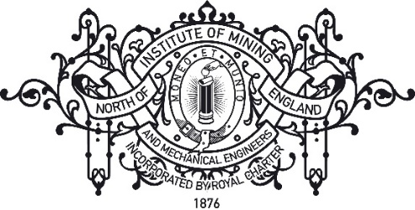

Process for Becoming a Corresponding Society of NEIMME
Approved by: COUNCIL | Date: May 2021

- Objective
To establish a procedure for an organisation external to the Institute to correspond with it in order to further the Institute’s Aims and Objectives. This process is separate from applying to be a member of an organisation.
- Aims
So that the Institute can benefit from corresponding with other organisations in order to raise its profile, attract new members and to further its Aims and Objectives though joint initiatives.
- Basic agreement between NEIMME and a partner organisation
A corresponding relationship between the Institute and another Organisation encourages both parties to:
- Maintain correspondence between each organisation.
- Promote each other’s activities and events.
- Aim to organise joint lectures and events where cost will be split equally between the Institute and the Corresponding Society.

- Process
Any potential Corresponding Society should share similar Objects to that of the Institute.

An application to be a Corresponding Society of the Institute should be made via the Hon. Secretary. The Aims and Objects of an applicant organisation will be checked, along with its governing document, to check that the applicant organisation would be of mutual benefit to the Institute.

The application must then be put to a vote at Council for approval.

If the application is rejected by Council then the applicant organisation will be informed of the reason(s) why. If the application is accepted the respective Presidents of NEIMME and the applicant organisation will sign an MoU based upon the template in Appendix A.

Appendix A – MoU Template for Corresponding Societies

Memorandum of Understanding (MoUl) between

The North of England Institute for Mining and Mechanical Engineers (NEIMME)

and

[Organisation]

The North of England Institute for Mining and Mechanical Engineers (NEIMME) is the Royal Chartered membership organisation for science, technology and engineering in the North; and exists to promote the advancement, and the facilitation of education and research in the public interest, of all aspects of science, and the art and practice of mining and engineering generally, and the prevention of accidents in mines.

[Organisation Aims and Objectives]

To help promote areas of science, technology and engineering of mutual interest, NEIMME and [Organisation] have established a Memorandum of Understanding (MoU) on the [DATE].

It is anticipated that this agreement will provide a positive and supporting additional incentive to help with both organisations membership recruitment and provide the foundation for future collaboration and communication between the NEIMME and [Organisation].

The organisations have agreed to
  - Promote each other's activities and events,
  - Display links to each other's websites (and other social media as appropriate)
  - Where appropriate, share online events (at a zero-cost or member-rate basis)

[SIGNATURE] | [SIGNATURE]
President of NEIMME | President of [Organisation]
[DATE] | [DATE]

