NEIMME-IOM3 Young Persons Lecture Competition 2021-22  Entry Form: NEIMME Local Heat | 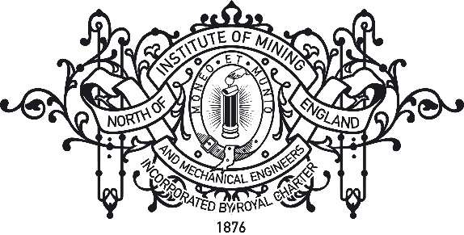

This entry form is to be completed by all competitors and returned to the NEIMME competition organiser: Andrew Dobrzanski (ad2021@cam.ac.uk)

Competitors must be 28 or under on the 1st of June 2022
Deadline for entries is 23:59 on Friday the 28th of January 2022

Name of Local Heat: North of England Institute of Mining and Mechanical Engineers
Date of Local Heat: Tuesday the 24th of February 2022
Competitors Name:
(This is the name that will be used on certificates)
Date of Birth:
IOM3 Membership Number (if applicable):
Name of Company/College/University:
Telephone Number (Mobile Preferred):
Contact Email:
Title of Presentation:
Abstract (150 words maximum –note that this abstract will be judged as part of your entry ):

The information provided will remain confidential and will only be used during the YPLC and subsequently destroyed securely.

