North of England Institute of  Mining and Mechanical Engineers  Founded 1852  Royal Charter 1876  A Local Society of the  Institute of Materials, Minerals  And Mining | 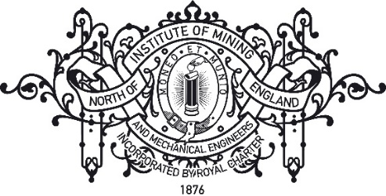
Dr A Dobrzański – Hon. Secretary | E: office@mininginstitute.org.uk
Dr DC Bell – Hon. Treasurer | W: www.mininginstitute.org.uk

1st February 2022

The Mining Institute - Major Thornton - Norman Watsons (Engineers) – Exiles
Annual Golf Competition

11.00am Friday 20th May 2022

Dear Golfers and friends

Hope everyone is keeping safe and healthy and free from Covid.

As usual this year we alternative and visit a golf course in Durham and good news our Past President John McCabe has booked “Heworth Golf Club” founded 1912 for the Golf Competition.

Understandably we are all getting a little older and if you do not want to be contacted in future let me know and your contact details will be removed. Similarly, if you know of someone whom we’ve missed let us know. Visitors/family and friends are also made most welcome invite them along.

The 2022 format will follow the new handicapping system and we will be playing the Men’s Yellow Course rating 69.5 – Slope Rating 118. Please remember to bring your home club handicap.

The 2021 prize winners were as follows and please remember to bring your engraved cups

Trophy | Points | 2021 Winner
Presidents Cup - best Stableford Score | 41 points | Stuart Porthouse
Major Thornton Cup runner up - best Stableford Score | 36 points | John McCabe
Grace Cup - best Gross Score | 92 | Glen Wills
The Engineers Cup - runner up best gross score | 93-19=74 | Malcolm Paisley
Garmonsway Trophy - best net score, | 97-25=72 | Ian Taylor
Northumberland Exiles Golfing Society NCB Cup - runner up net score | 94-21=94 | Allan Brewes
Visitor’s Cup - best Stableford score | 35 points | Alan Wills
The Schwarz Holywell Ltd (Visitor) - Gross Cup | 77 | Paul Smith

The cost £35.00 (Members of golf club TBC) includes Tea/Coffee and bacon sandwich on arrival, 18 holes of golf and a one-course meal. Please arrive early to accommodate any changes.

As number’s are reducing the only prizes will be the cups hence, the reduced cost of the competition.

Please complete and return the application form ASAP.

Yours sincerely

Stuart Porthouse

NEIMME

THE ANNUAL GOLF COMPETITION 2021
MINING INSTITUTE

The Mining Institute - Major Thornton - Norman Watsons (Engineers) – Exiles Golf Competition

2022 GOLF COMPETITION - APPLICATION FORM

Heworth Golf Club 11.00am Friday 20th MAY 2022
RETURN DEADLINE FRIDAY 13th May 2022

Please complete and return application form with £35.00 cheque made payable to ‘NEIMME’

Post to:

Stuart Porthouse, 8 Careen Crescent, Middle Herrington, Sunderland, SR3 3TF.

Email: stuartporthouse@me.com Telephone: 0191 528 2643 Mobile 077 658 64397

NAME: ........................................................................Club………................................................

Handicap Index……............

ADDRESS: ....................................................................................................................................

....................................................................................................................................................

Post Code..............................

Email address.............................................................................................................................

Telephone............................................

Names of partners in 3/4 ball can be arranged……………………………………………………………………..

Golf Buggies are available please contact the club professional 0191-4384223

